"Take your color healing to the next level"

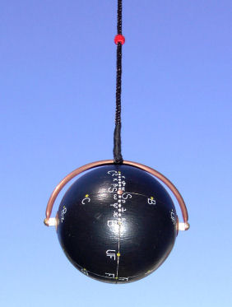

Introducing Universal Pendulums from Jozef Baj's Line

Universal Pendulums 5.4 & 6.6 are pendulums with magnetic battery designed by French
dowsers L. Chaumery, A. Belizal and P.A. Morel and modified and crafted by Polish
radiesthetic inventor and designer Jozef Baj.
UP 5.4 has multiple uses. It's built from specially selected wood in the shape of a sphere
about 50 mm in diameter and weighs about 50g. Inside, along its North-South axis there
is a battery in the form of 4 half-spheres, which amplify the radiation. The biggest
advantage of UP 5.4 is its very high sensitivity, that's why it is very useful in medical
diagnosing, scientific research, as well as everyday dowsing tasks, like checking food,
checking and dosing of medicine and herbs, etc. It can also be used in chromotherapy in
early and final stages of treatment using other pendulums (e.g. UP 6.6).
UP 6.6 is about 60 mm in diameter, has a battery of 6 half-spheres and weighs about 75 g.
The biggest advantage of UP 6.6 is its high intensity of radiation making it especially useful
in treating diseases in more advanced stages; it can destroy viruses, bacteria and parasites
easier and extends its use in research.

- Working with both: UP 5.4 and 6.6 will not lower the operator's bio-energy level.
- Both pendulums will not react to mental commands if the level of radiation is too
low or too high, making it safer to use.
- Universal Pendulums designed by Jozef Baj don’t require tuning – they come ready
to use

There is a copper (or brass) bow attached at the poles and a thread that can be moved
along the bow. To make adjustments – you can either move the bow with the thread in
the middle of the bow along the electromagnetic equator or move the bow to one of the
meridians and move the thread on the bow.
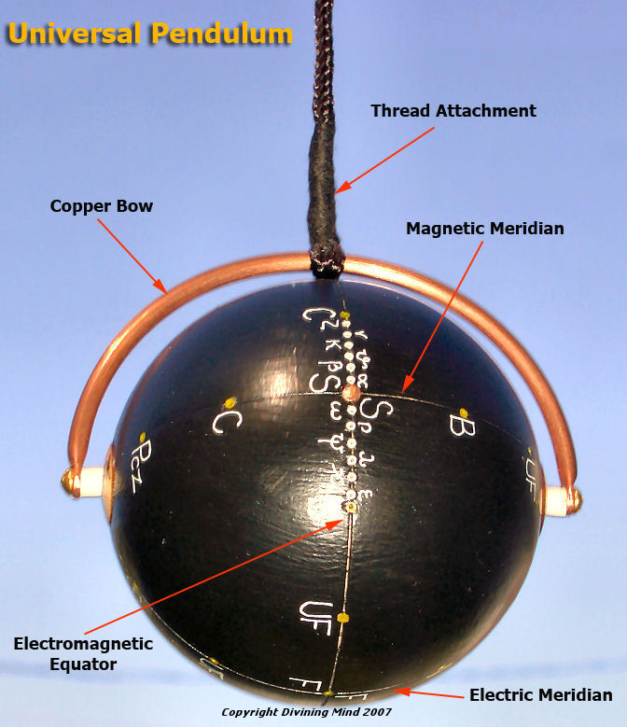

Please note that markings on the pendulum shown above are in Polish. The pendulum itself has English markings.

Both equator and meridian in UP 5.4 & UP 6.6 are divided into 400 degrees and marked as follows:
On the electric meridian (work on the first, red bead) there are 12 colors - gray, black,
infrared, red, orange, yellow, green, blue, indigo, violet, ultraviolet and white. The electric meridian intersects the equator in points R(ed) on one side and V(iolet) on the other side.
The electric meridian vibrations are harmful and should be used only for research.
On the magnetic meridian (work on the second, green bead) there are two copper pins at
the intersection with the equator and 12 colors: gray, black, infrared, red, orange, yellow,
green, blue, indigo, violet, ultraviolet and white. Those vibrations can be used in therapy.
The electromagnetic equator (work on the third, blue bead) is the most important in
therapy. There are 24 marks:
Gray, alpha α, beta β, theta θ, xi ξ, nu ν, zeta ζ, black, infrared, red, orange, yellow,
green, blue, indigo, violet, ultraviolet, white, epsilon ε, kappa κ, lambda λ, psi ψ,
rho ρ, omega ω.
Colors from gray to white are used in a regular fashion in chromotherapy, frequencies
from gray to black are used mostly in treating cancers (esp. alpha and beta), colors from
gray to white are used mostly in treating TB (esp. omega and rho).
When used as a receiver in bands gray-black and gray-white it can detect:
Alpha - underground magnetic anomalies
Beta - radiation of underground water veins
Theta ,xi , nu - harmful emission from e.g. TV, computer, etc.
Zeta - radioactivity
Omega to epsilon - harmful radiation of high voltage lines, electrical appliances, etc.
It is very important to slide the string on the bow very carefully in this area.

Final Notes
1. While working with other pendulums, UPs should be kept away so their radiation wouldn't influence the reading - 1.5-2 m min. for UP 5.4, 5.5-6 m min. for UP 6.6.
2. When not in use they should be set to green + or white on the electromagnetic equator.

3. Avoid dropping or hitting the pendulum as this may change the alignment of the markings
and may require re-tuning.

